**Cacious siamunyanga**

Introduction to databases

assignment

Task 1 – Design

a) Retro Club ERD

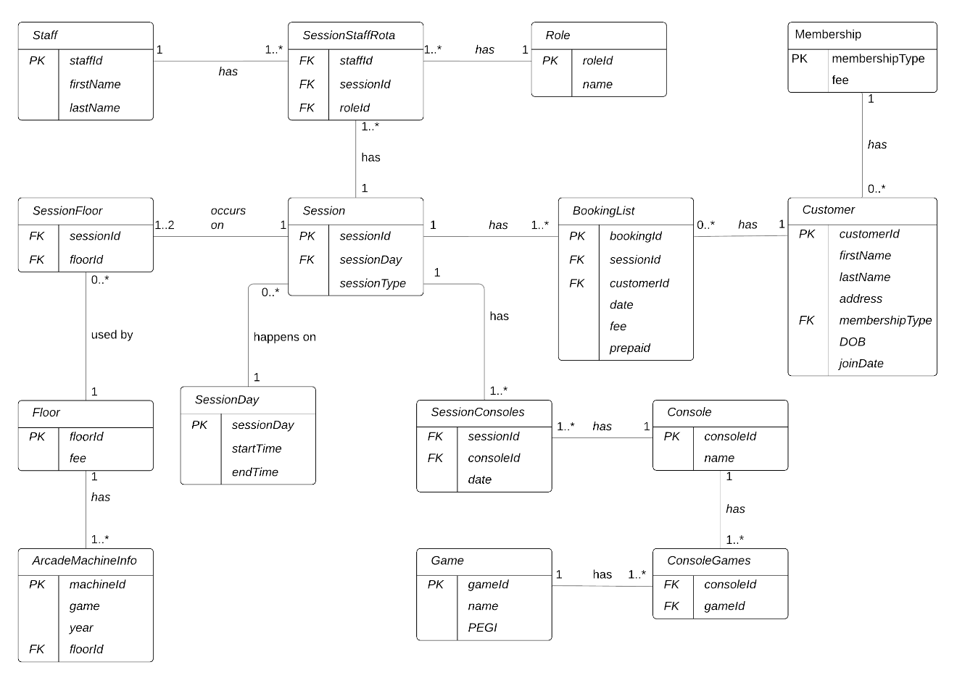

b)

Normalization of the sample data provided resulted in a much more efficient ERD that will lead to less redundancy when updating and deleting values in the database tables. This is so because, some unnecessary fields had to be removed, such as the “Member y/n” field in the “Booking List” table that I found redundant as this can be solved with queries that give much more accurate date for verification if someone is a member or not from the new “Customer” table as seen in the designed ERD.

Other fields were regrouped to create new entities for a much more accurate representation and, I believe, better data entry, analysis and more. An example is the ambiguity that could exists in the “Session and fees” table where two session numbers would have to be entered for the same session if the session happened on both the 1st and 2nd floor on the same day. Extracting the floor and the fee fields to create a new “Floor” table allows for the proper representation of the session and the floor. Therefore, their manipulation becomes easier. The sample data also shows different prices for each floor even if it not specified explicitly in the club’s background. Such normalization would allow changing of that logic to be easy rather than going through the whole table to change every instance if an error was ever made.

c)

1) Session

|  |  |  |  |  |
| --- | --- | --- | --- | --- |
| **fieldName** | **dataType** | **size** | **constraint** | **description** |
| sessionId | varChar | 20 | Primary key | identifies a session |
| sessionDay | varChar | 10 | Foreign key | Identifies and links to the sessionDay table |
| sessionType | varChar | 10 | Not null | Specifies the type of session |

2) SessionDay

|  |  |  |  |  |
| --- | --- | --- | --- | --- |
| **fieldName** | **dataType** | **size** | **constraint** | **description** |
| sessionDay | varChar | 10 | Primary key | identifies the day the session is occurring |
| startTime | Time |  | Not null | The time the session begins |
| endTime | Time |  | Not null | The time the session ends |

3) SessionFloor

|  |  |  |  |  |
| --- | --- | --- | --- | --- |
| **fieldName** | **dataType** | **size** | **constraint** | **description** |
| sessionId | varChar | 20 | Foreign key | identifies a session and links to the Session table |
| floorId | int | 1 | Foreign key | Identifies and links to the Floor table |

4) Floor

|  |  |  |  |  |
| --- | --- | --- | --- | --- |
| **fieldName** | **dataType** | **size** | **constraint** | **description** |
| floorId | Int | 1 | Primary key | Identifies each floor in the building |
| fee | int | 4 | Not null | The fees for each floor |

5) SessionStaffRota

|  |  |  |  |  |
| --- | --- | --- | --- | --- |
| **fieldName** | **dataType** | **size** | **constraint** | **description** |
| staffId | varChar | 10 | Foreign key | identifies the staff on duty and links to the Staff table |
| sessionId | varChar | 20 | Foreign key | identifies a session and links to the Session table |
| roleId | varChar | 5 | Foreign key | Identifies the staff’s role and links to the Role table |

6) Role

|  |  |  |  |  |
| --- | --- | --- | --- | --- |
| **fieldName** | **dataType** | **size** | **constraint** | **description** |
| roleId | varChar | 5 | Primary key | identifies each role |
| name | varChar | 20 | Foreign key | The name of each role |

7) Staff

|  |  |  |  |  |
| --- | --- | --- | --- | --- |
| **fieldName** | **dataType** | **size** | **constraint** | **description** |
| staffId | varChar | 10 | Primary key | identifies the staff |
| firstName | varChar | 30 | Not null | The staff’s first name |
| lastName | varChar | 30 | Not null | The staff’s last name |

8) BookingList

|  |  |  |  |  |
| --- | --- | --- | --- | --- |
| **fieldName** | **dataType** | **size** | **constraint** | **description** |
| bookingId | varChar | 40 | Primary key | identifies each booking |
| sessionId | varChar | 20 | Foreign key | identifies a session and links to the Session table |
| customerId | varChar | 40 | Foreign key | Identifies a customer and links to the Customer table |
| date | date |  | Not null | The date the booking was made |
| fee | int | 10 | Not null | Total cost of the booking |
| prepaid | boolean | 1 | Not null | shows whether a customer prepaid or not |

9) Customer

|  |  |  |  |  |
| --- | --- | --- | --- | --- |
| **fieldName** | **dataType** | **size** | **constraint** | **description** |
| customerId | varChar | 40 | Primary key | identifies each customer |
| firstName | varChar | 30 | Not null | Customer’s first name |
| lastName | varChar | 30 | Not null | Customer’s last name |
| address | varChar | 70 | Not null | The customer’s reachable address |
| membershipType | varChar | 15 | Foreign key | The type of membership the customer is on and links to the Membership table |
| joinDate | date |  | Not null | Date membership was acquired |
| DOB | date |  | Not null | The customer’s date of birth |

10) Membership

|  |  |  |  |  |
| --- | --- | --- | --- | --- |
| **fieldName** | **dataType** | **size** | **constraint** | **description** |
| membershipType | varChar | 15 | Primary key | The type of membership the customer is on |
| fee | int | 10 | Not null | The membership fee |

11) SessionConsoles

|  |  |  |  |  |
| --- | --- | --- | --- | --- |
| **fieldName** | **dataType** | **size** | **constraint** | **description** |
| sessionId | varChar | 20 | Foreign key | Identifies a session and links to the Session table |
| consoleId | varChar | 5 | Foreign key | Identifies a console and links to the Console table |
| date | date |  | Not null | The date the console was taken for use |

12) Console

|  |  |  |  |  |
| --- | --- | --- | --- | --- |
| **fieldName** | **dataType** | **size** | **constraint** | **description** |
| consoleId | varChar | 5 | Primary key | Identifies a console |
| name | varChar | 20 | Not null | Console’s name or code e.g PS1 |

13) ConsoleGames

|  |  |  |  |  |
| --- | --- | --- | --- | --- |
| **fieldName** | **dataType** | **size** | **constraint** | **description** |
| consoleId | varChar | 5 | Foreign key | Identifies a console and links to the Console table |
| gameId | varChar | 10 | Foreign key | Identifies a game and links to the Game table |

14) Games

|  |  |  |  |  |
| --- | --- | --- | --- | --- |
| **fieldName** | **dataType** | **size** | **constraint** | **description** |
| gameId | varChar | 10 | Primary key | Identifies a game |
| name | varChar | 20 | Not null | The name of the game |
| PEGI | varChar | 5 |  | The rating of the game |

15) ArcadeMachineInfo

|  |  |  |  |  |
| --- | --- | --- | --- | --- |
| **fieldName** | **dataType** | **size** | **constraint** | **description** |
| machineId | varChar | 5 | Primary key | Identifies each gaming machine |
| game | varChar | 20 | Not null | The name of the game |
| year | int | 4 | Not null | The year the game was made |
| floorId | int | 1 | Foreign Key | The floor the machine is on |

TASK 2 – SQL

a)